Annual Report – 2024
(All information from January to December - 2024)
1. Name of the Centre: Bio-inspired Design and Optimization Centre (BIODOC)
Address: Adjacent to NCC office, Ground Floor, Multi level parking building, MIT-B
Phone Number: 9620532297
Email Centre: biodoc.mitblr@manipal.edu
Coordinator Email: patil.arun@manipal.edu
Centre Photo: more than 8 MB
Year of Establishment of Centre: Feb 2024
Name of the Coordinator: Dr. Arun Y. Patil
Members: Dr. Shrirang A Kulkarni, Dr. Tusar Kanti Mishra, Dr. Rajshekhar Choudhari, Dr. Deepa Prabhu, Dr. Ashish Sharma, Dr. Bharath Srinivasan, Dr. Manasa Nune (MIRM) and Dr. Jyothi Prasanna (MIRM).

2. Brief about Centre Unique selling points (200 words limit):
Vision: To be a world-renowned centre for bio-inspired design by fostering multi-
disciplinary research on cutting edge technologies.

Mission: To advance the field of bio-inspired design towards building a dynamic
ecosystem of creative and bio-inspired thinkers, scientists, technocrats, and designers.

Objectives:
- Promote Nature-Inspired Innovation: Develop innovative solutions by studying and applying principles from nature to address modern challenges in engineering, technology, and sustainability.
- Advance Sustainable Development Goals (SDGs): Focus on creating technologies and practices that contribute to SDG 12 (Responsible Consumption and Production), SDG 14 (Life Below Water), and SDG 15 (Life on Land), aligning the centre's goals with global sustainability efforts.
- Create a knowledge Hub: Develop an initial version of digital library by December 2025, of proven bio-inspired designs helpful to researchers and learners.
- Develop a digital twin mechanism to verify and aid in gauging the efficiency and accuracy of existing designs or bio-inspired systems to enhance the features of our products.

3. Activities at the centre:
1. MOU with Central Manufacturing Technological Institute (CMTI) has yielded in research collaboration for applying to a fund of 40 Lakhs for VGST (under review). Students from 6th Sem of Electronics and Communication Engineering (10 students) and Computer Science and Engineering (10 students) will be undergoing the Internships with training at Sensor lab and Smart Manufacturing Lab at CMTI, Bengaluru respectively. CAPP program of Rs. 1 lakh for the benefit of students and faculty for niche area training and research work.
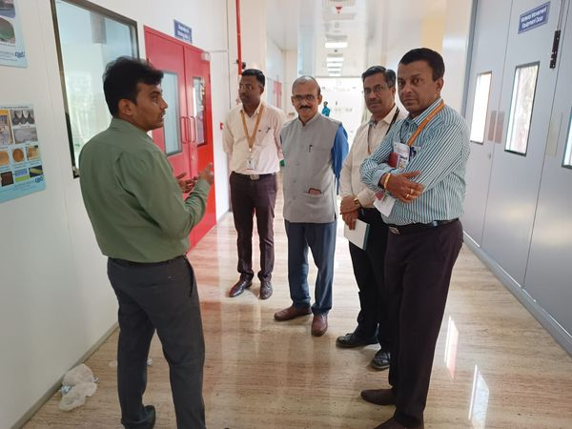
2. Central Food Technological Research Institute (CFTRI) had visited. The discussion resulted in identifying the problem areas for consultancy work on Food, AI and Molecular Simulation.
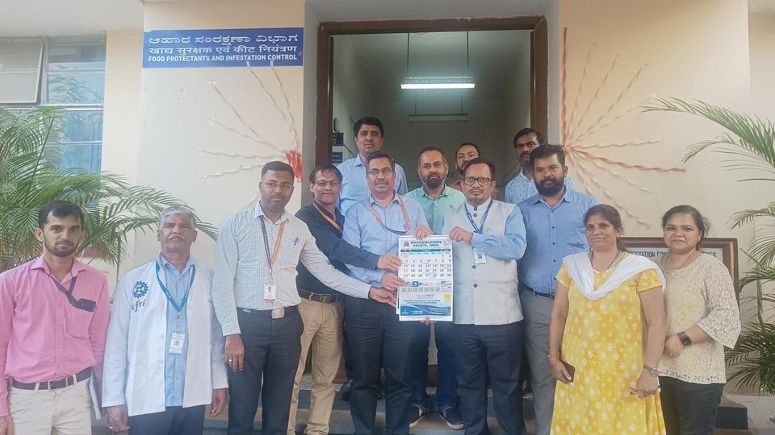
System for monitoring agricultural crops in stocks and method thereof (Patent-1)
Inventors: Dr. Tusar Kanti Mishra, Dr. Shrirang A Kulkarni and Dr. Arun Y. Patil
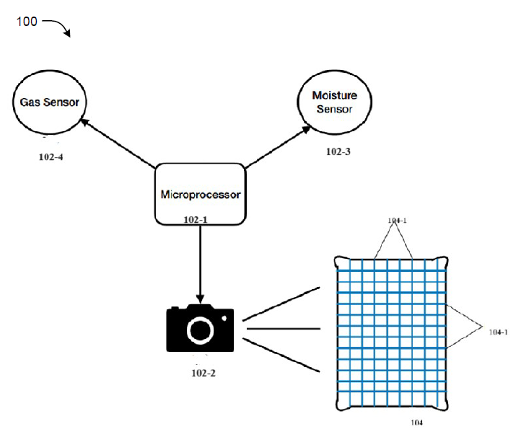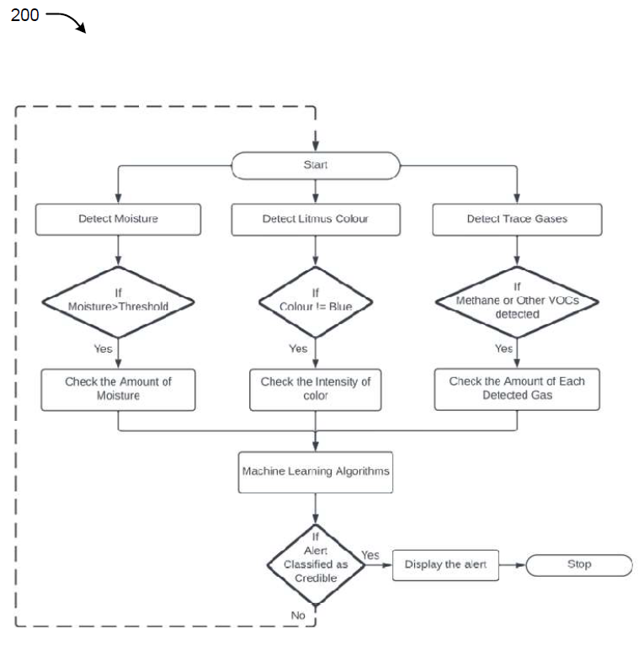

- Research Activities

1. Early potential malignancy detection: Preliminary phase-1, working prototype model is getting built for trial tests at JNMC Belagavi. In this regard a 3D Bio printer machine is asked for quotation and will be available by Feb 2025 in BIODOC lab. The cost of the machine is Rs. 25,00,000.
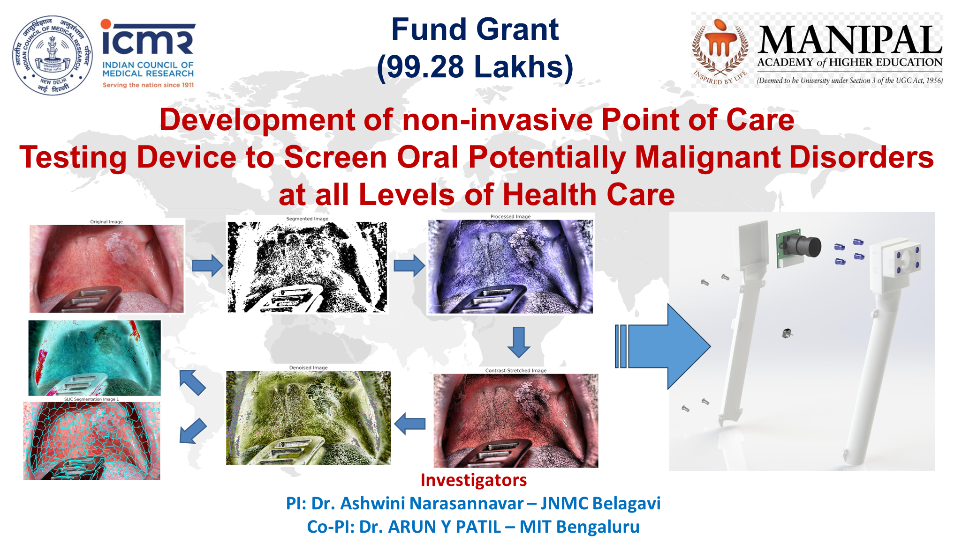
2. Elevate Funding Work: First of its kind of material model will be developed at MIT Bengaluru by the combination of sheep horn and hydroxyapatite to reach a temperature range of 1200ºC - 1400ºC. The work will be patented shortly with the composition and possible output results.

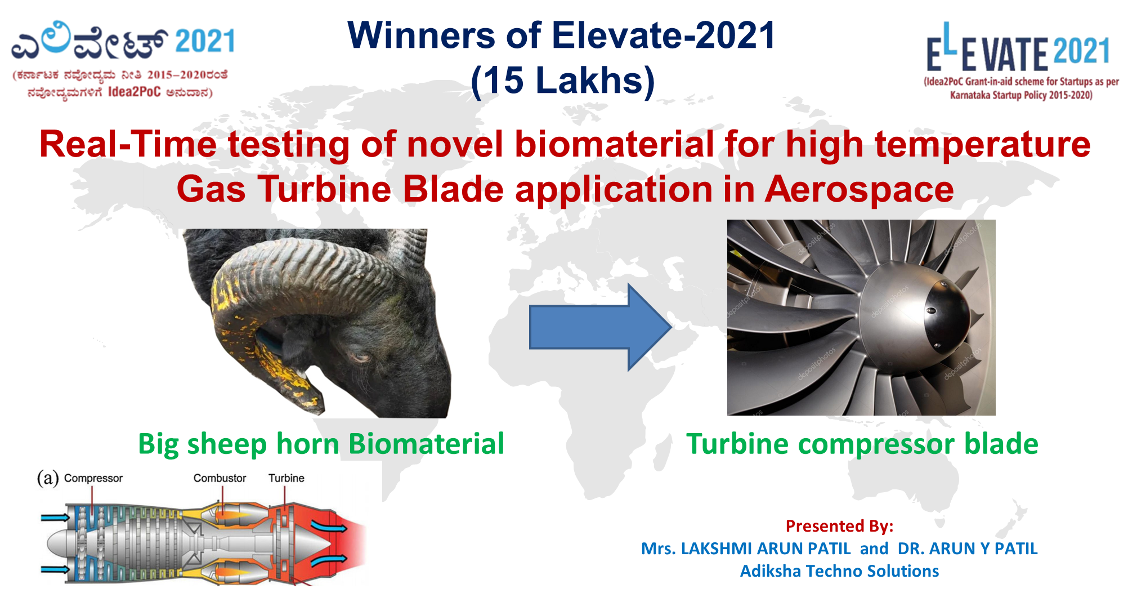
- Dragon fly Study for discretization (Patent-2): A novel bio-inspired method for circular/cylindrical/spherical geometrical shapes mesh generation applying discrete process of finite element analysis. (Patent No. 202441006804)
Inventors: Dr. Arun Y. Patil, Dr. Shrirang A Kulkarni and Dr. Tusar Kanti Mishra

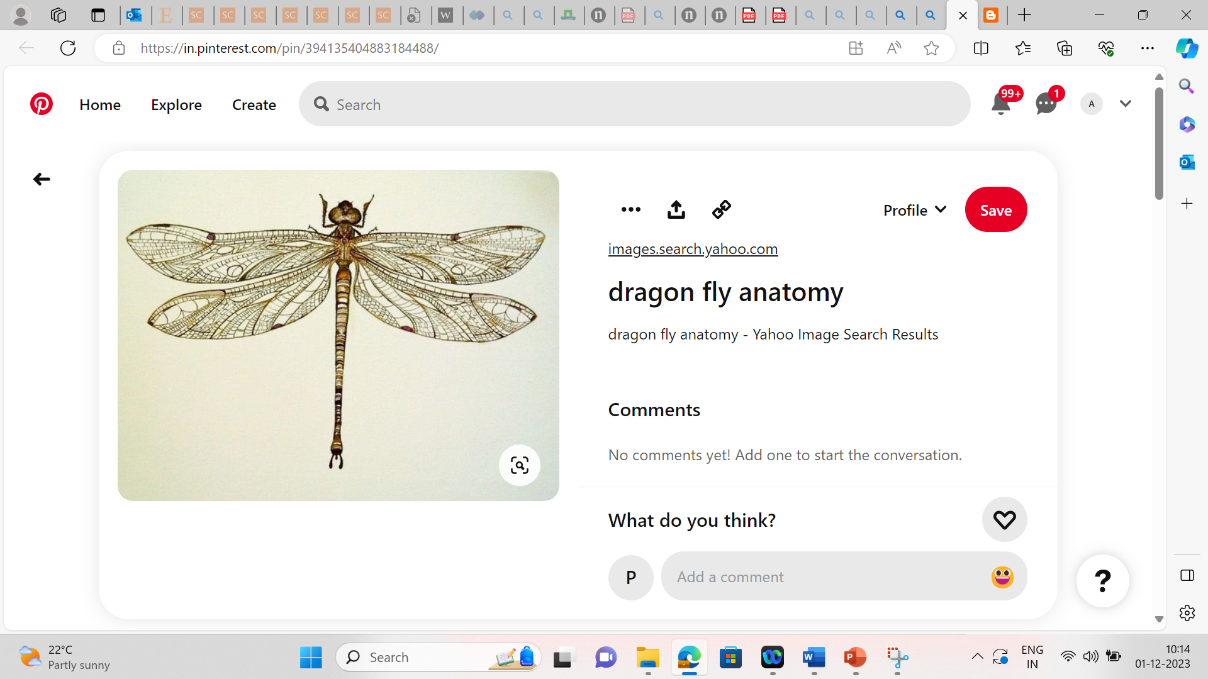
Patent published
- System and method for determining the purity of gold in non-stone ornaments (Patent-3): A novel Weight and Machine Learning based methodology to detect the percentage of purity in gold for non-stone ornaments. (Patent No. PD00021283)
Inventors: Dr. Arun Y. Patil, Dr. Shrirang A Kulkarni, Mr. Kaustubh Agrawal, Reg.No. 235890202, Mr. Vallamkonda Sri Sai Pranav, Reg. No. 235891284, Mr. Jayant Shekhar, Reg. No. 235805480 and Mr. Sanjeev Raj Kurady, Reg. No. 235816194

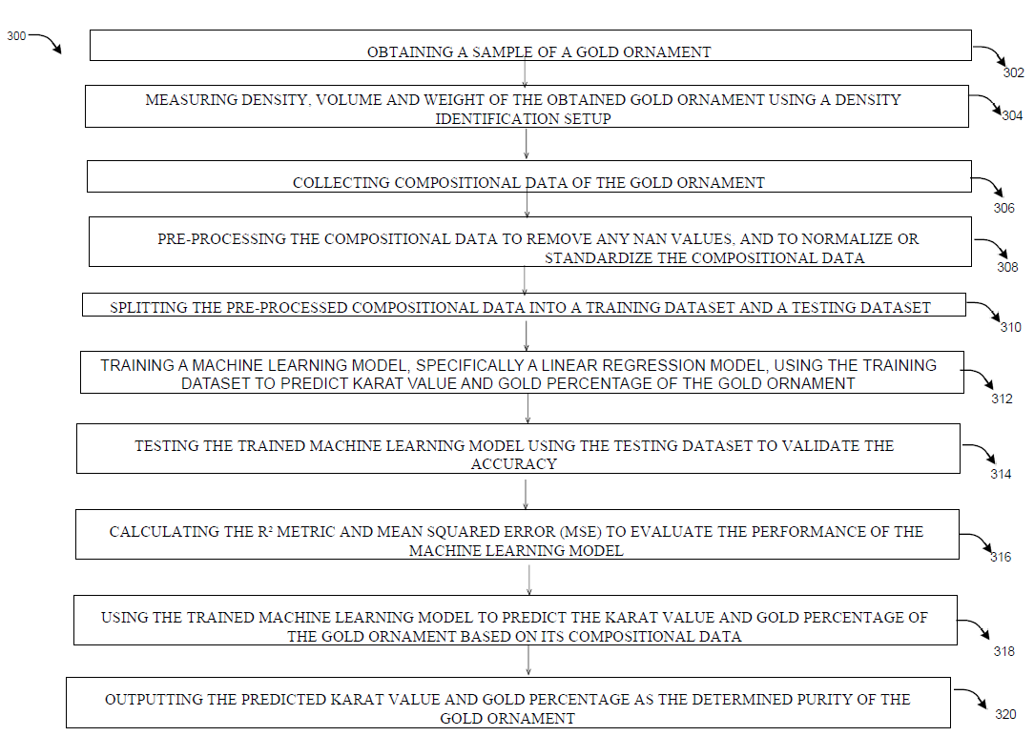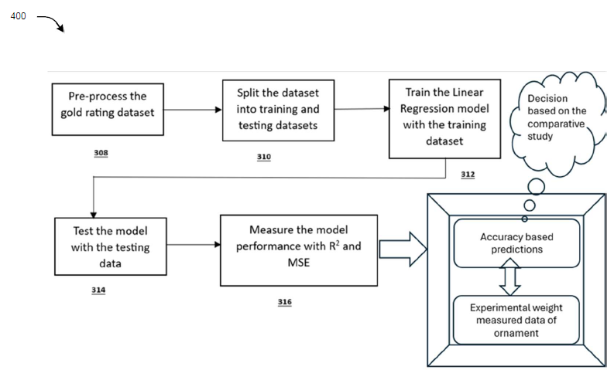
Patent published

- Bio-inspired database system and method (Patent-4): A novel Weight and Machine learning based methodology to detect the percentage of purity in gold for non-stone ornaments. (Patent No. PD00021882)
Inventors: Dr. Arun Y. Patil and Mr. Gururaj Fatepur (Faculty in KLE Technological University)
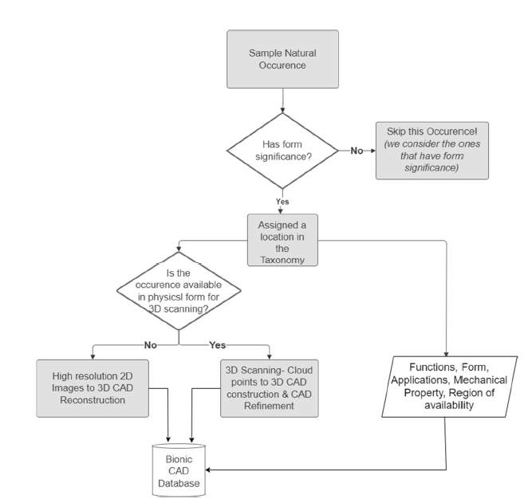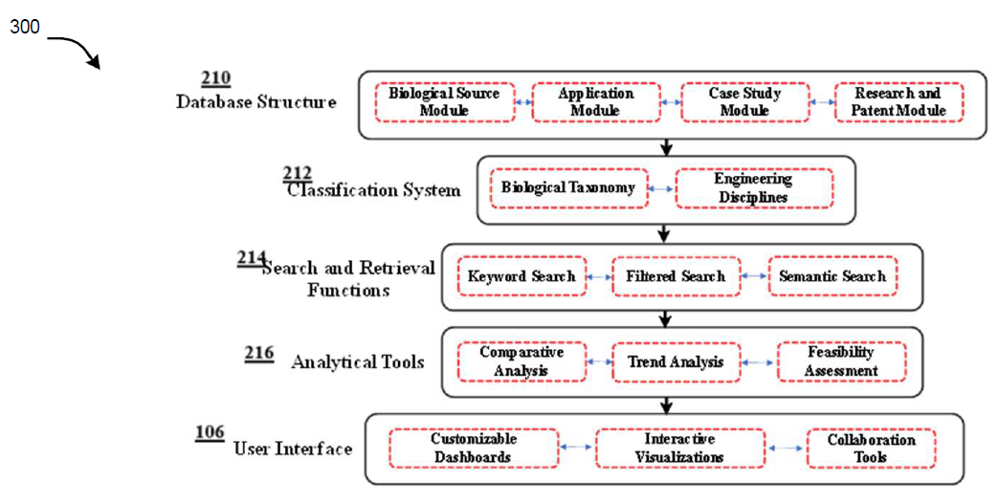
Patent filed
- AI-Powered Ayurvedic Health Monitor Integrated with Smart Refrigeration (Patent-5): The current work will be a biomedical health monitoring device catering to three kinds of ayurvedic doshas implemented according to individual body condition and even the weather conditions such as spring, fall, autumn and winter seasons. (Patent No. Submitted to Attorney-Khurana & Khurana)
Inventors: Dr. Arun Y. Patil and Akshat Bijalwan (235816172)

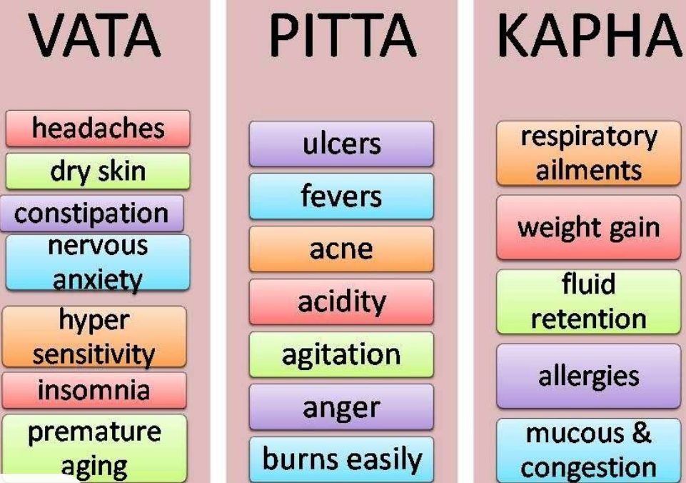
Patent ready to be filed

5. Research Publication:

- Fattepur, G., Patil, A.Y., Kumar, P. et al. Bio-inspired designs: leveraging biological brilliance in mechanical engineering—an overview. 3 Biotech 14, 312 (2024). https://doi.org/10.1007/s13205-024-04153-w, IF:2.6 (SCI, WoS and Scopus)[Q1]
- A. Y. Patil , T. Kundu , and R. Kumar , Finite element analysis megatrends: A road less travelled, Comput. Appl. Eng. Educ. (2024), e22721. DOI: https://doi.org/10.1002/cae.22721, IF: 2.9 (SCIE, WoS and Scopus) [Q1]
- Tajammul Hussain M. Mysore, Arun Y. Patil, Chandrashekhar Hegde, M A Sudeept, Raman Kumar, Manzoore Elahi M. Soudagar, IMR Fattah, Apatite Insights: From Synthesis to Biomedical Applications, European Journal of Polymer, Elsevier, Accepted, IF:6 (SCIE, WoS and Scopus) [Q1] doi.org/10.1016/j.eurpolymj.2024.112842.
- Tajammul Hussain Mysore, Arun Patil, N. R. Banapurmath, Chandrashekhar Hegde4, Raman Kumar, Yunus Khan Tatagar Mohammad, Feasibility study of Scapula bone as a next generation material for biomedical applications, Journal of Applied Animal Research, Taylor and Francis, Accepted, IF:1.4 (SCI, WoS and Scopus) [Q1], https://doi.org/10.1080/09712119.2024.2337174.
- Vishalagoud S Patil, Arun Y. Patil, Piyush Kumar, Anil Kumar, Raman Kumar, Chander Prakash, P. C. Arunakumara, Mallikarjungouda B Patil, Keshavmurthy R, Jaber M. Asiri, Yunus Khan T M, Shaik Mohamed Shamsudeen, Enhancing Material Properties with a Sustainable Wood-Quartz-HDPE Composite: A Study on Strength, Cogent Engineering, 10.1080/23311916.2024.2434946, IF:2.1 (ESCI, WoS and Scopus)[Q2]

- Any SDG-related activities:

Currently centre is working in the following SDG’s. Namely,

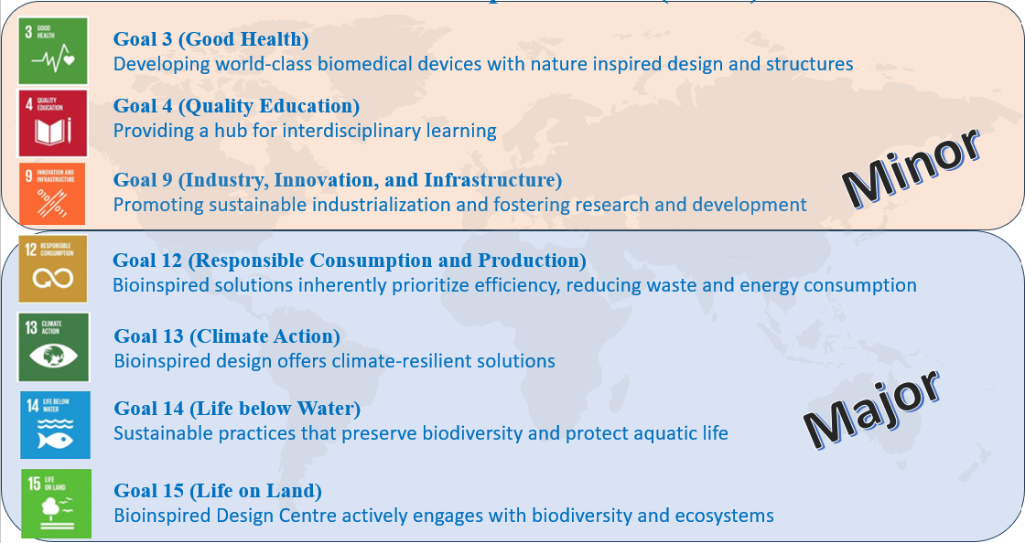

We have initiated collaboration with following universities with BIODOC
- Queensland University of Technology, Australia: Dr. Mohamed Shahriar, Associate Professor (Area: Biomedical device development and Engineering) (As per QS Ranking 2024:43)
- Singapore University of Technology and Design, Singapore: Centre Head - Dr. Pablo Valdivia y Alvarado, Associate Professor (Area: Bio-inspired design, Soft robots and sensors) (As per QS Ranking 2024:429)
- University of North Carolina at Charlotte US -Erina B Joyee, Ph.D. Assistant Professor, Mechanical Engineering & Engineering Science (As per QS Ranking 2024:1001-1200)

7. Awards & recognition:
NA

8. List of ongoing projects/ research grants:

Sl. No. | Title | Funding Agency | Name of the PI | Amount | Date
1 | Development of non-invasive Point of Care Testing Device to Screen Oral Potentially Malignant Disorders at all Levels of Health Care | ICMR, New Delhi | Dr. Ashiwini Narasannavar, JNMC, Belagavi  Dr. Arun Y. Patil (Co-PI) | 99,28,000  (Rs. 1500000 received from JNMC, Belagavi as Phase-I work) | Dec 2023
2 | Orchestrating the future of cancer detection with Quantum Innovation: Oral Premalignant detection device OPMD | CMTI, Heavy Industries Ltd, Bengaluru | Dr. Arun Y. Patil | 1,66,817 | Mar 2024

List of projects applied

Sl. No. | Title | Funding Agency | Name of the PI | Amount | Date
1 | Feasibility study of Deccani Sheep Horn as a Novel Biomaterial for 3D Bio printing Applications in Prosthetic Limbs, Exoskeletons, and Knee Joint Implants | DST, New Delhi | Dr. Arun Y. Patil (PI)  Dr. Manasa Nune  (Co-PI)  Dr. Naveen kumar (Co-PI) IIT Ropar | 19586813 | Oct 2024
2. | Smart hydrogel with nanoparticle mediated bio-sensing and targeted  drug delivery an innovative approach to treat ER positive cancers | DST, New Delhi | Dr. Manasa Nune  (PI)  Dr. Arun Y. Patil (Co-PI) | 15097400 | Sept 2024
3. | Identification of Arterial Blockages via Fatty Acid Profiling and Lipid based Diagnostic Techniques | Sree Ramakrishna Paramahamsa Research Grant | Dr. Arun Y. Patil (PI)  Dr. Ashiwini Narasannavar, JNMC, Belagavi | 28000000 | Sep 2024
4. | Nature-Inspired Biological Material Analysis: Lady Termite Skin as a Sustainable Polyethylene Bag Replacement | VGST | Dr. Arun Y. Patil (PI)  Dr. Shrirang A Kulkarni (Co-PI)  Mr. Harsha, Scientist D, CMTI (Co-PI) | 4000000 | Jun 2024

9. Photo gallery (Please provide photos in jpg format)

Note: Photos in .jpg format (Maximum 6 photos with caption)
Size of each photograph should be more than 8 MB

